# CSCE 5465.001 - USABILITY TESTING GROUP PROJECT PART 3

**GROUP 11**

**SNEAKPEAK – Sneaker Store**

**TEAM DETAILS**

|  |  |
| --- | --- |
| **Team member** | **Email** |
| Chenchu Siva Koushik Vemula | [Chenchusivakoushikvemula@my.unt.edu](mailto:Chenchusivakoushikvemula@my.unt.edu) |
| Nikhila Mannem | [NikhilaMannem@my.unt.edu](mailto:NikhilaMannem@my.unt.edu) |
| Nihal Jonnala | [nihaljonnala@my.unt.edu](mailto:nihaljonnala@my.unt.edu) |
| Teja kamesh gattu | [tejakameshgattu@my.unt.edu](mailto:tejakameshgattu@my.unt.edu) |
| Javali Subha Mapati | [javalisubhamapati@my.unt.edu](mailto:javalisubhamapati@my.unt.edu) |
| Sarika kandey | [Sarikakandey@my.unt.edu](mailto:Sarikakandey@my.unt.edu) |
| Srilipi Jadala | [srilipijadala@my.unt.edu](mailto:srilipijadala@my.unt.edu) |
| Bhanu Prasad Krishna Murthy | [BhanuPrasadKrishnaMurthy@my.unt.edu](mailto:BhanuPrasadKrishnaMurthy@my.unt.edu) |
| Bhavana Varma Penmetsa | [Bhavanavarmapenmetsa@my.unt.edu](mailto:Bhavanavarmapenmetsa@my.unt.edu) |
| Sai Nikitha Ponnathota | [SaiNikithaPonathota@my.unt.edu](mailto:SaiNikithaPonathota@my.unt.edu) |

**Localization Assessment Issues**

1. **Issue Name: Language Discrepancy:** Language Discrepancy in a Localization Assessment denotes the need to achieve a thorough and precise localization that harmonizes with the intended user experience across various linguistic environments.

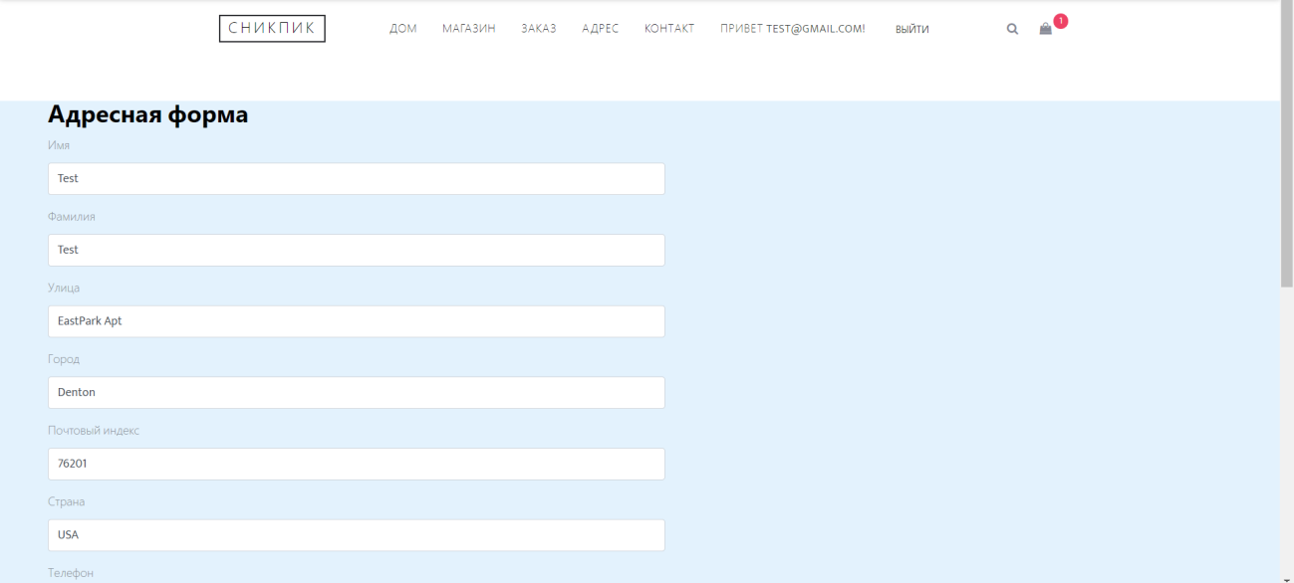

## Fixed: Updated this Page

Despite modifying the page interface, there is an issue where specific nouns or essential terms are not undergoing accurate translation. Addressing this is vital to maintain consistency and clarity in diverse language settings.

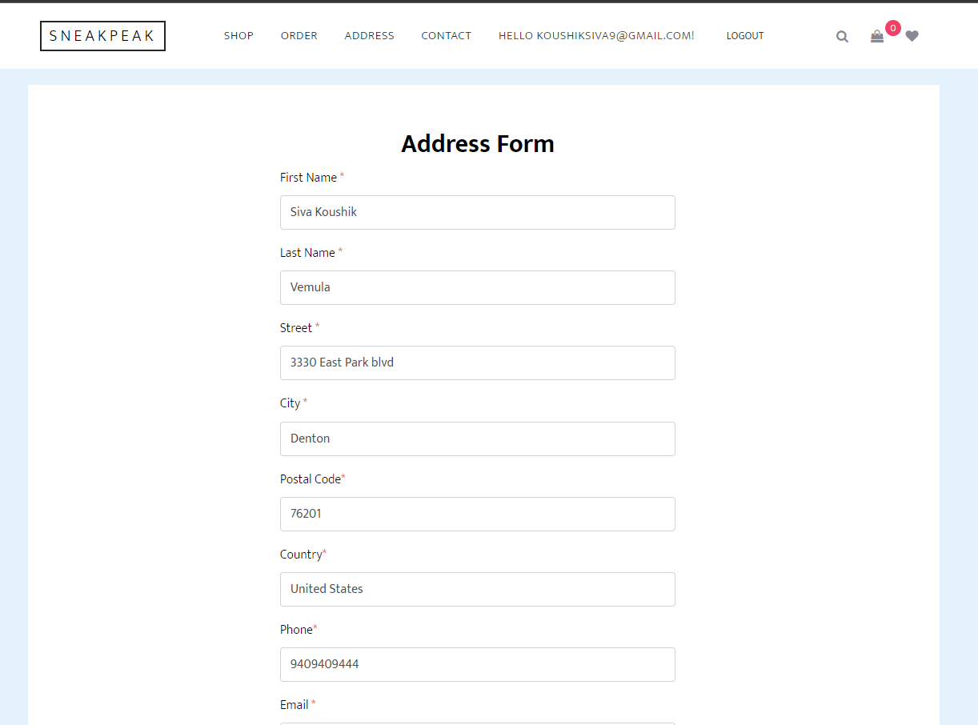

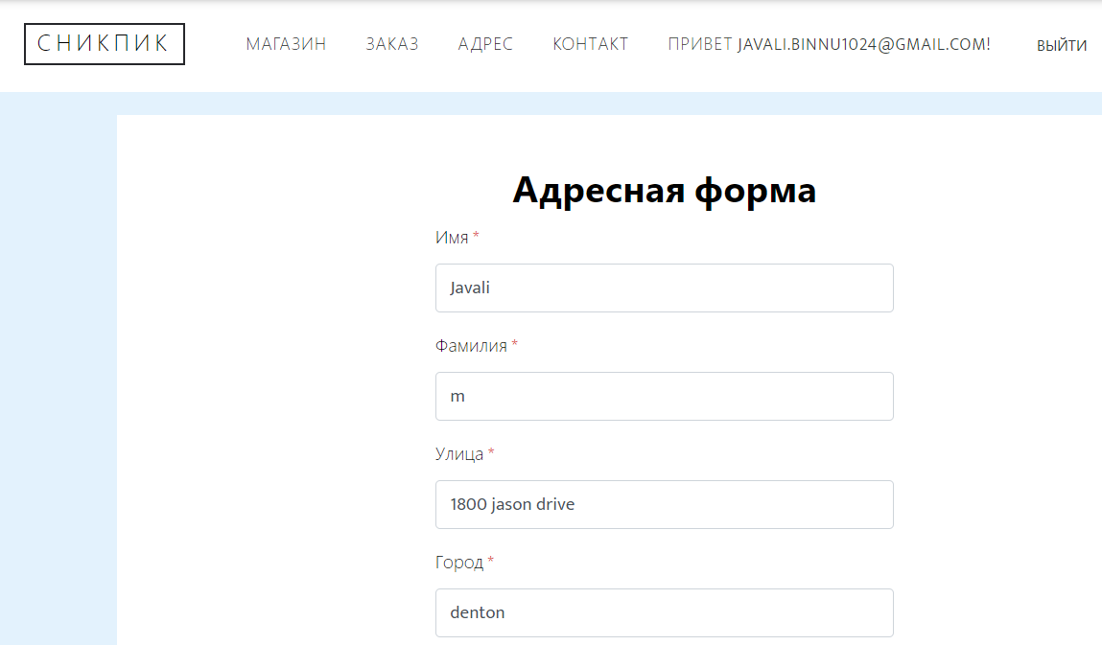

## Issue Name: Inconsistent Date Formats

The problem known as "Inconsistent Date Formats" arises from the existence of diverse date formats in different localized versions, creating confusion for users. This confusion stems from the presentation of dates in varying styles, posing a risk of misunderstandings.

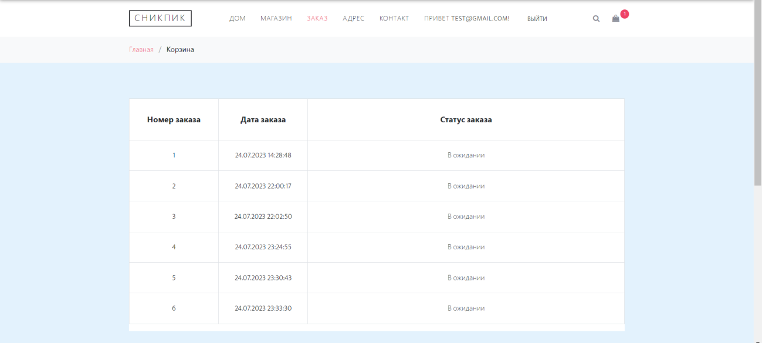

## Fixed: Order date formatting

To address this issue, the proposed solution is to implement changes that standardize and update date formatting across all localized versions. This approach aims to establish consistency in how dates are showcased, ultimately improving the user experience, minimizing confusion, and fostering a more cohesive and user-friendly interface.

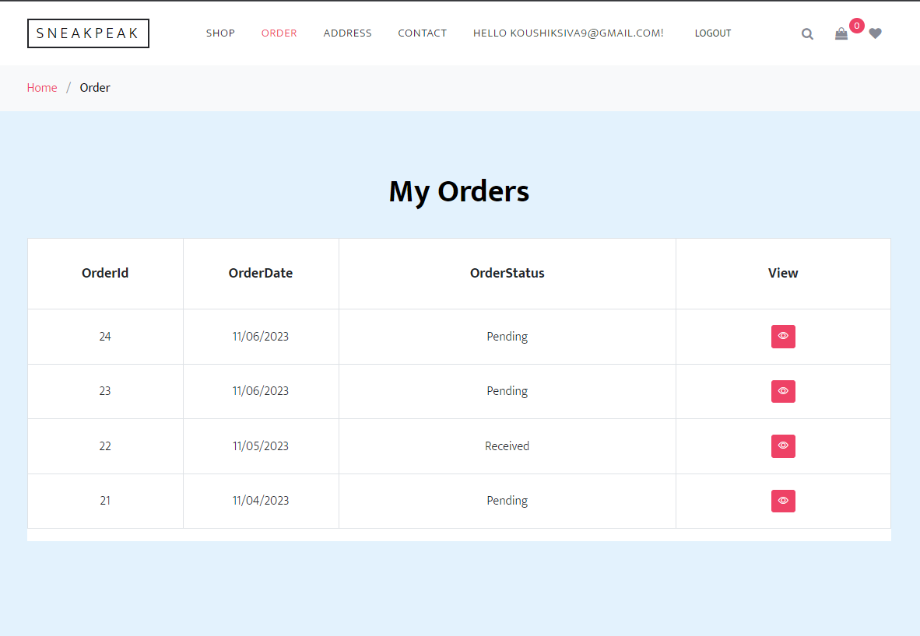

## Issue Name: Cultural Insensitivity

Identify instances where localized content contains culturally insensitive or inappropriate references.

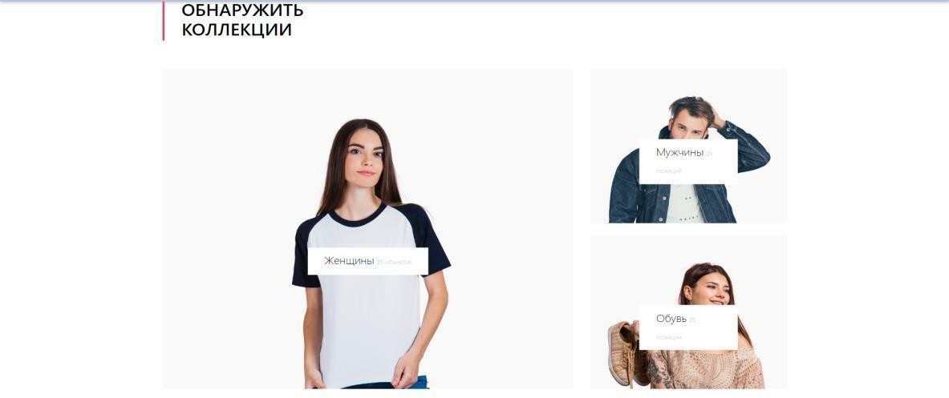

**Fixed:** To address this issue, the solution included incorporating the necessary references. This modification ensures that the page guides users to the appropriate categories without perpetuating cultural insensitivity, ultimately creating a more inclusive and considerate user experience.

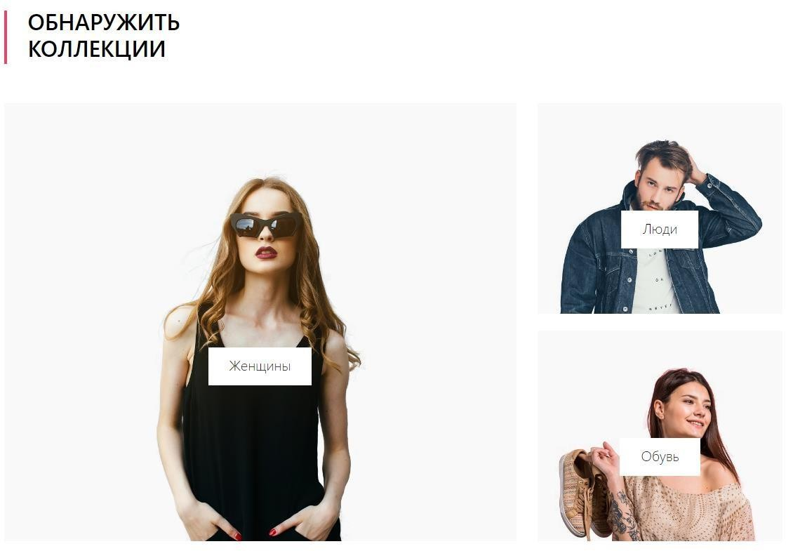

**Color Blindness Assessment Issues**

## Issue Name: Insufficient Contrast Levels

This problem, named "Inadequate Contrast Levels," centers on recognizing situations where the text or interface elements lack sufficient contrast for individuals with color blindness. This can pose challenges for them in comprehending and navigating the content efficiently

**Fixed**: The solution to this issue was a straightforward but impactful one. The text formats were modified to black, boosting the contrast and enhancing the content's accessibility for users with color blindness. This modification guarantees a more distinct and easily perceivable display, fostering inclusivity and improving the overall user experience for everyone.



## Issue Name: Relying on Color for Information-cart page rendering issue

Find cases where crucial information relies solely on color coding, rendering it inaccessible to color-blind users.

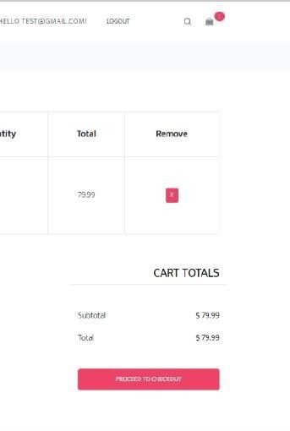

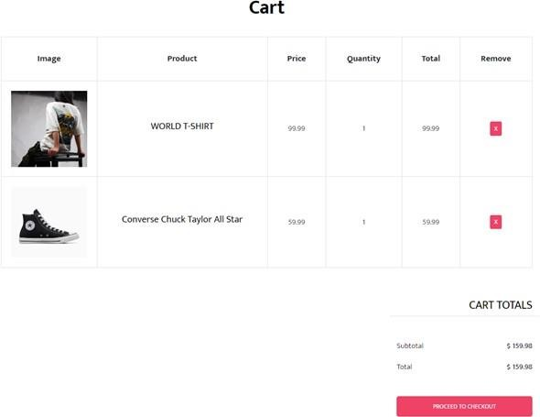**Fixed:** The issue with the cart page rendering was successfully addressed and fixed. Users were experiencing problems with how the cart page was displayed, and the resolution involved implementing corrections to ensure proper rendering. As a result, users can now expect an improved and seamless display of the cart page without encountering the previously identified issue.

## Issue Name: Varied Color Application

The problem, named "Varied Color Application," involves recognizing inconsistencies in how colors are used across different sections of the application. This inconsistency can be confusing, especially for users with color blindness, and stems from the application interface using different color schemes in various areas.

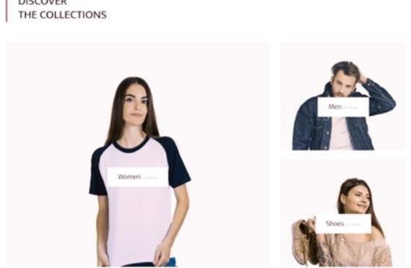

## Fixed:

To tackle this issue, a thorough evaluation and modification of color schemes were undertaken. The objective was to guarantee a uniform and well-coordinated use of colors throughout the application, reducing confusion and improving the user experience, particularly for individuals with color blindness. The solution aims to create a more unified visual presentation across all parts of the application.

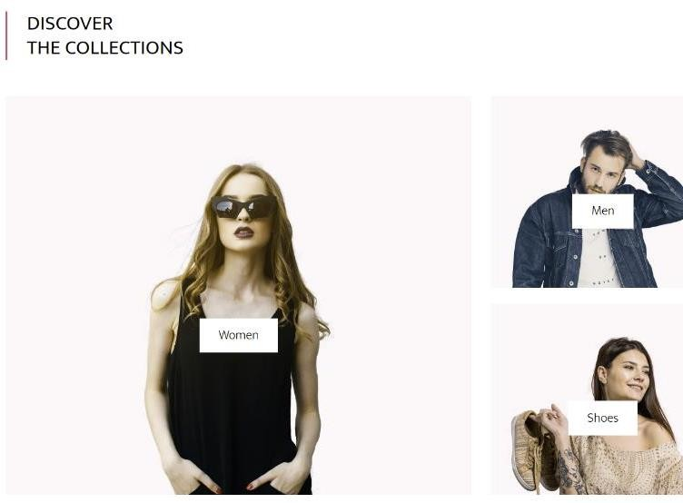

## Issue Name: Ineffectual Color-Blind Mode

Tackling the issue labeled "Ineffective Color-Blind Mode," the primary emphasis lies in evaluating how well the color-blind mode addresses problems associated with color blindness in the application.



## Fixed:

The objective is to guarantee that the color-blind mode not only works properly but is also fine- tuned to deliver an excellent user experience for individuals with different levels of color blindness.

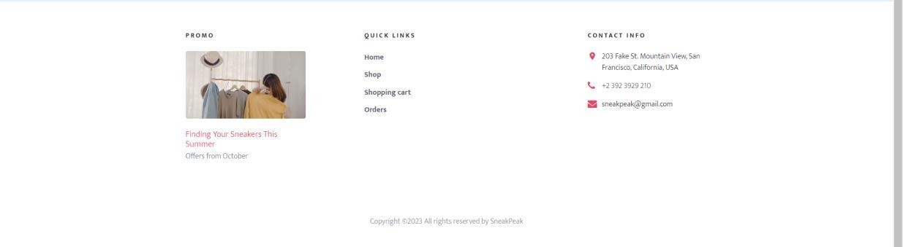

**Usability Testing Issues**

## Issue Name: Cart Functionality Malfunction

The issue named "Cart Functionality Malfunction" pertains to disruptions in the regular functioning of the cart feature. Users may have faced challenges when attempting to add, remove, or process items in their shopping cart.

* + Go to the SneakPeak Store website.
  + Peruse the product listings.
  + Choose a product for purchase.
  + Select the "Add to Cart" button.

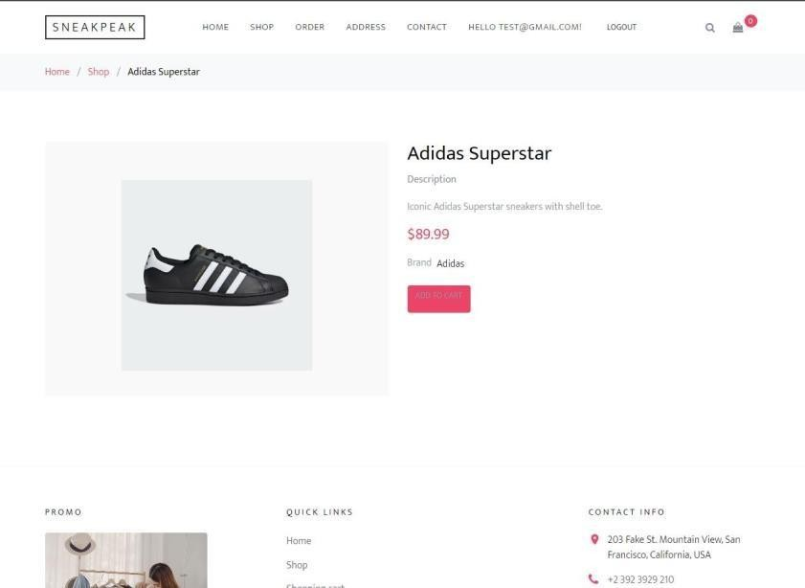

## Fixed: Add to Cart works

Note that the product fails to appear in the shopping cart as anticipated. The cart remains devoid of the selected item, and no confirmation message is displayed.

Reattempt the process with different products, consistently encountering the same issue. Model Id is not passed into the addtocart method. So, no products added.

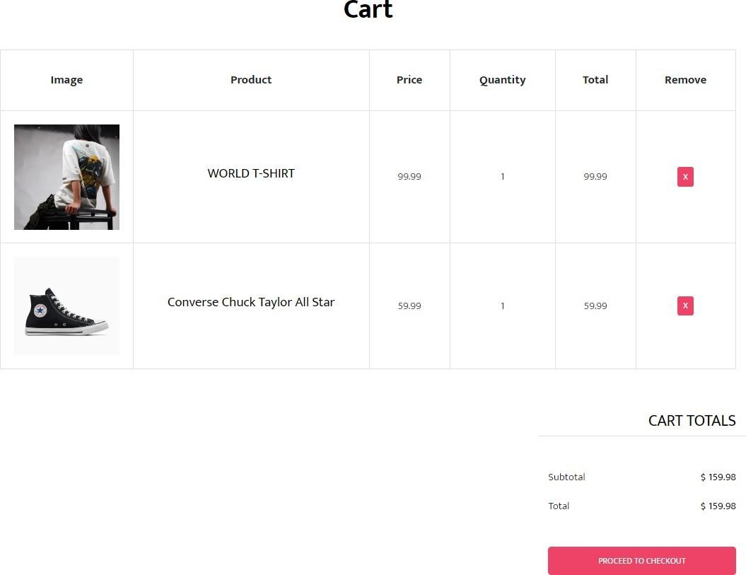

## Issue Name: Total Calculation is wrong.

The issue labeled "Incorrect Total Calculation" involves inaccuracies in the total calculation, where users have faced discrepancies in the computed totals, risking errors in financial transactions or order summaries. The solution to this problem includes a detailed review and adjustment of the calculation process to guarantee that the total aligns accurately with the intended values.

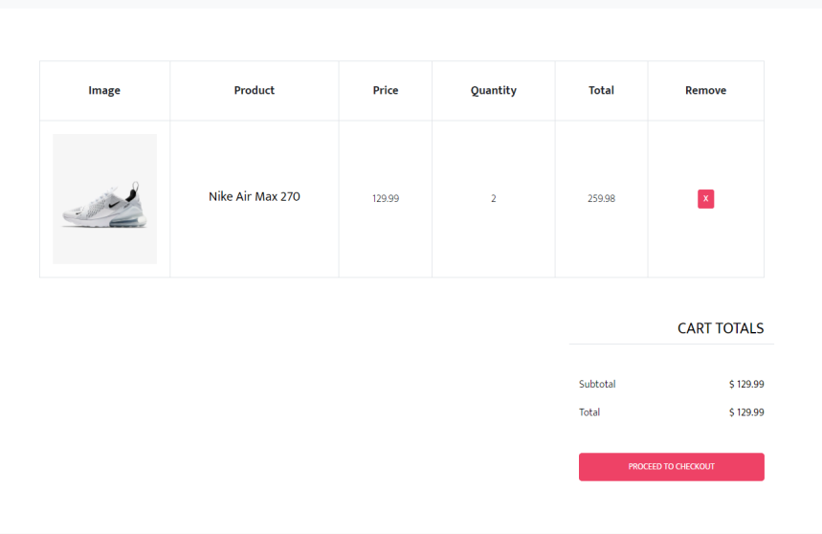

**Fixed:** Cart Page calculation works correct

* + Code Identification: Identify the code responsible for total calculations within the system.
  + Evaluate Logic: Scrutinize the code for any flaws or inaccuracies.
  + Test Case Creation: Generate specific test scenarios to elicit the issue.
  + Introduce Errors: Implement code alterations that lead to incorrect total calculations.
  + Conduct Testing: Execute test cases consistently to replicate the problem.
  + Record and Document: Keep records of details, code modifications, and issue observations.
  + Debug and Rectify: Developers rectify the code issues identified in the preceding step.
  + Reassessment: Re-run the tests to confirm that the problem has been resolved after code adjustments.

## Issue Name: Search function is not working.

The problem identified as "Search function is not working" brought attention to a malfunction in the search feature, preventing users from obtaining results based on their queries.

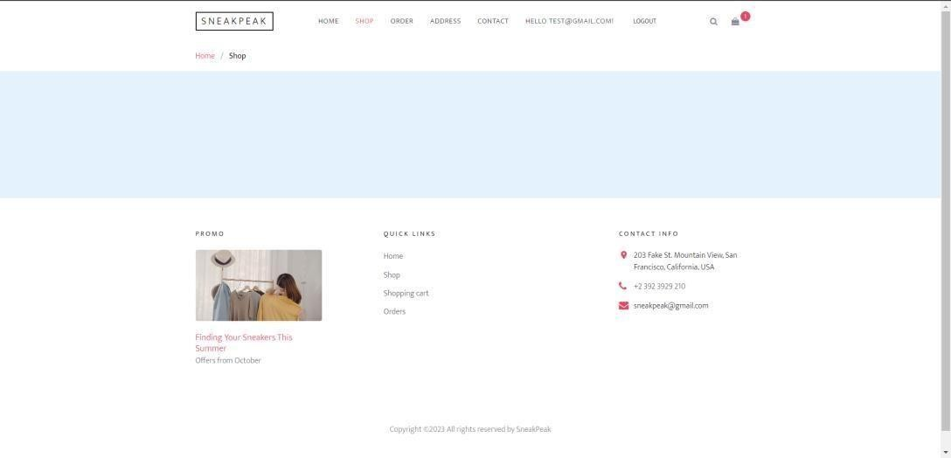

**Fixed:** Search now works properly based on keyword

It has been fixed to deliver accurate and relevant results based on entered keywords. This enhancement ensures that users can now enjoy a smooth and efficient search experience on the platform.

* + Identify Search Function Error
  + Optimize Database Query
  + Secure User Input Handling
  + Review Search Algorithm
  + User Interface Validation
  + Effective Error Handling
  + Deployment and Monitoring



## Issue Name: Checkout Displays Only One Product.

The problem identified as "Checkout Displays Only One Product" signaled an issue where the checkout interface was showing just one product,potentially leading to user confusion.

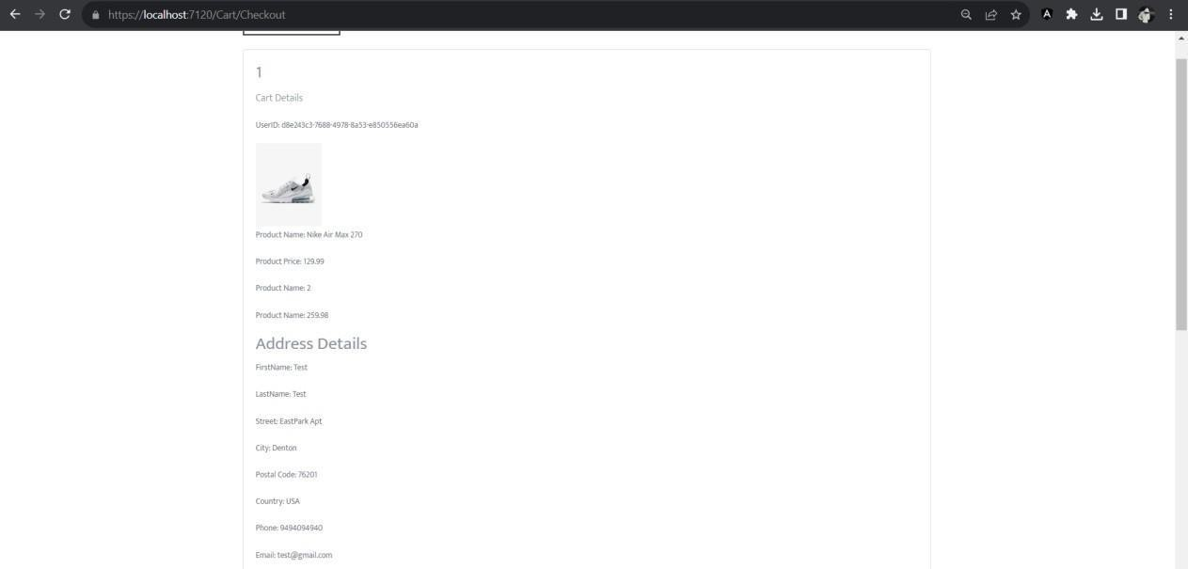

**Fixed:** Checkout now shows all the products checked out

The solution focused on resolving this limitation, resulting in an enhancement of the checkout functionality. Users will now observe that the checkout process accurately presents all selected products for purchase. This improvement ensures a more thorough and precise representation of items during checkout, ultimately elevating the overall user experience.

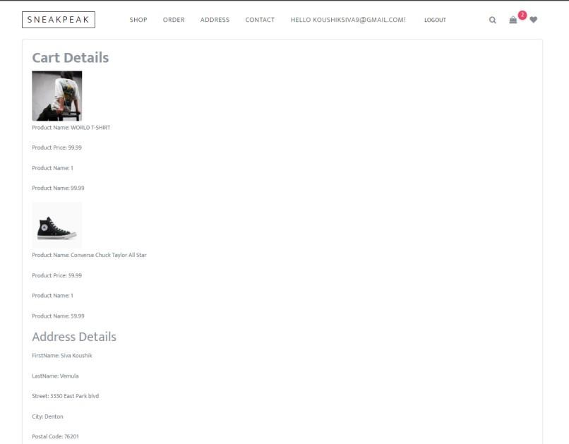

## Issue Name: Payment Failures

The challenge labeled "Payment Failure" is related to obstacles users face while trying to make payments, particularly when utilizing expired credit cards.

Payment processing errors during the checkout, leading to a frustrating shopping experience. To replicate, select items, add to cart, and proceed to payment, where users consistently face processing issues, such as errors, declines, or unexplained failures.

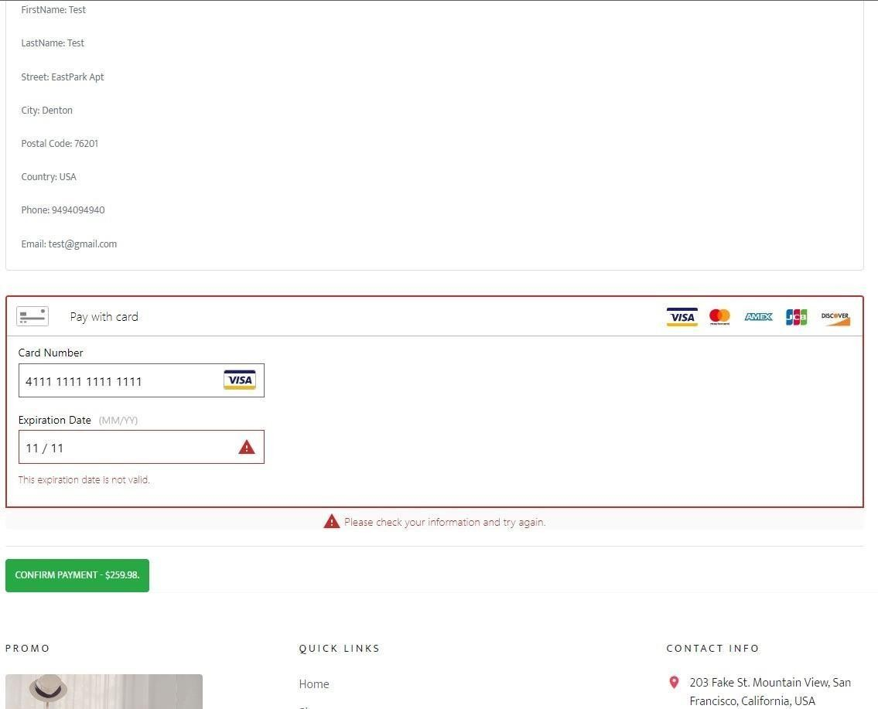

**Fixed**: Issue is using expired credit cards it will work for cards that are not expired.

The solution addresses this issue with a specific adjustment: the system now accommodates payments made using credit cards that are still valid. This modification enhances the payment process, enabling users to complete transactions smoothly without being impeded by the use of expired credit cards.

## Issue Name: Links not navigating to specific category:

* + Examine the HTML code and JavaScript linked to the said link or button to identify potential reasons for the navigation issue.
  + Apply any necessary modifications to the code to resolve the problem, ensuring that the link directs users to the desired product category page.

The problem labeled "Links not navigating to specific category" indicates an issue where links are ineffective in guiding users to their intended product categories. This issue can impede navigation and cause frustration for users attempting to access specific sections.

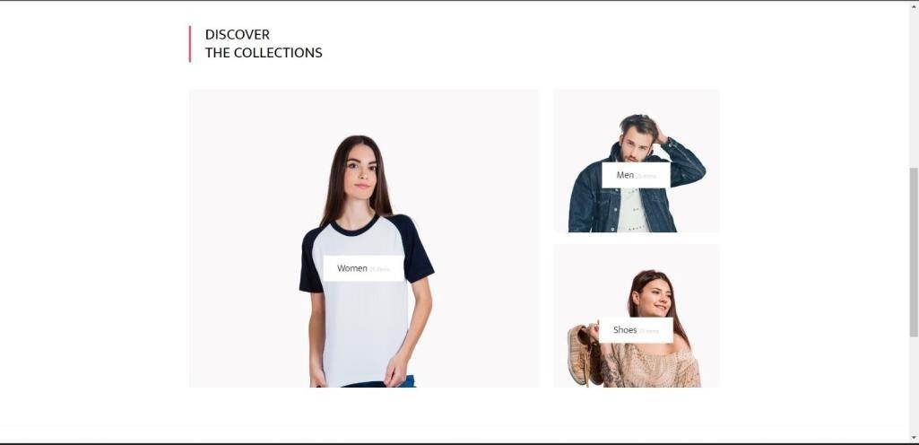

**Fixed:** The solution entailed identifying and resolving the root cause, ensuring that the links now accurately lead users to their designated product categories

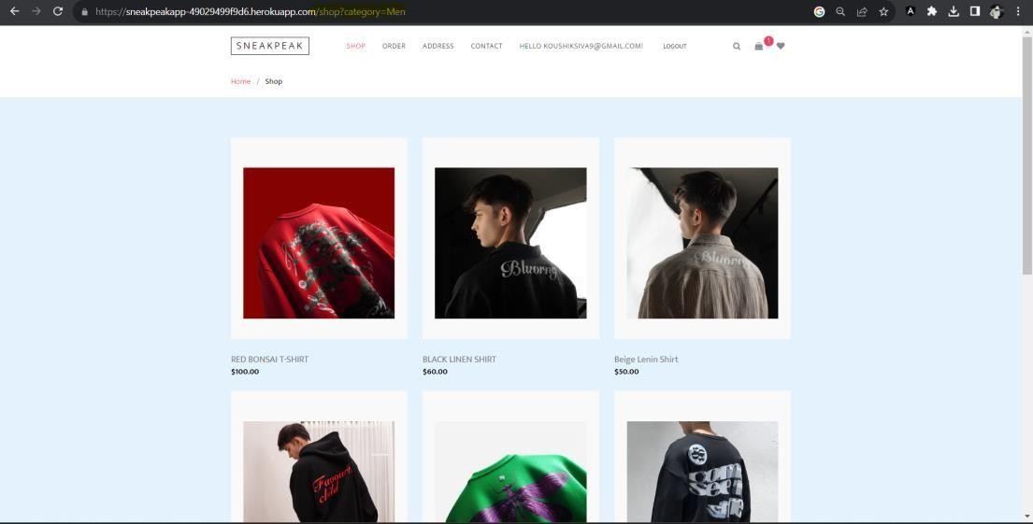

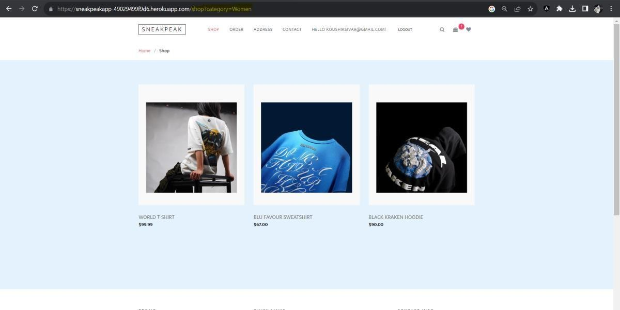

## Issue Name: Address Not Updating

The problem labeled "Address Not Updating" centers on users facing difficulties in updating their addresses, causing inconvenience, particularly when having accurate and current address information is essential.

Scrutinize the interaction with the database to confirm precise storage of updated address details. Investigate the presence of any data validation issues that might hinder address updates.

Integrate error-handling mechanisms to offer transparent user feedback in case an address update fails.

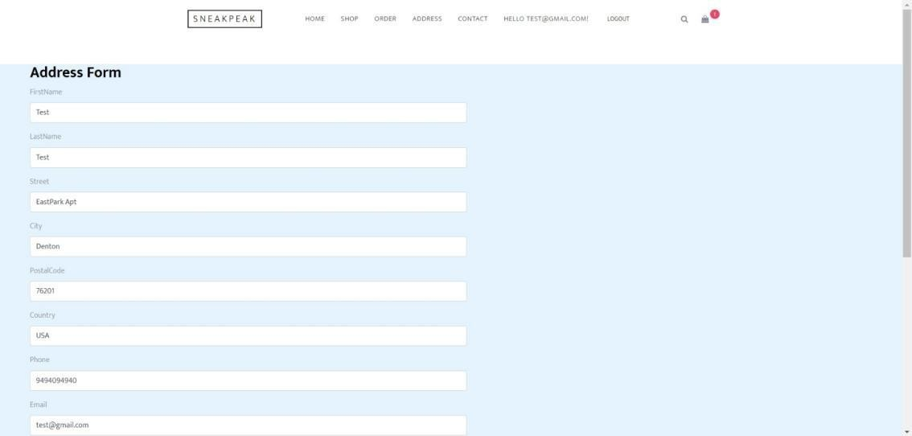

Address Form Update Issue is fixed. The solution to this issue includes identifying and addressing the root causes that hinder address updates. After the resolution, users can effortlessly update their addresses, guaranteeing that the system precisely captures their current and intended location details.

## Issue: Order Page Missing Order Details

Issue 15, named "Missing Order Details on Order Page," brings attention to a scenario where users faced a lack of essential order information on the order page, potentially causing confusion and inconvenience for customers who depend on comprehensive details.

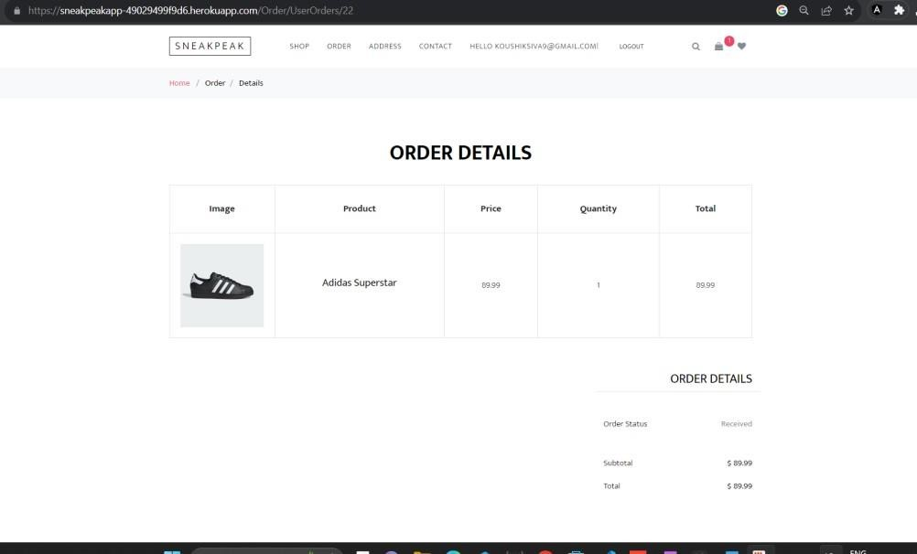

**Fixed:** This concern has been effectively resolved. The solution included implementing measures to guarantee the proper display of all pertinent order details on the order page. Users can now retrieve comprehensive and precise information about their orders, enhancing transparency and contributing to a more satisfactory overall user experience.

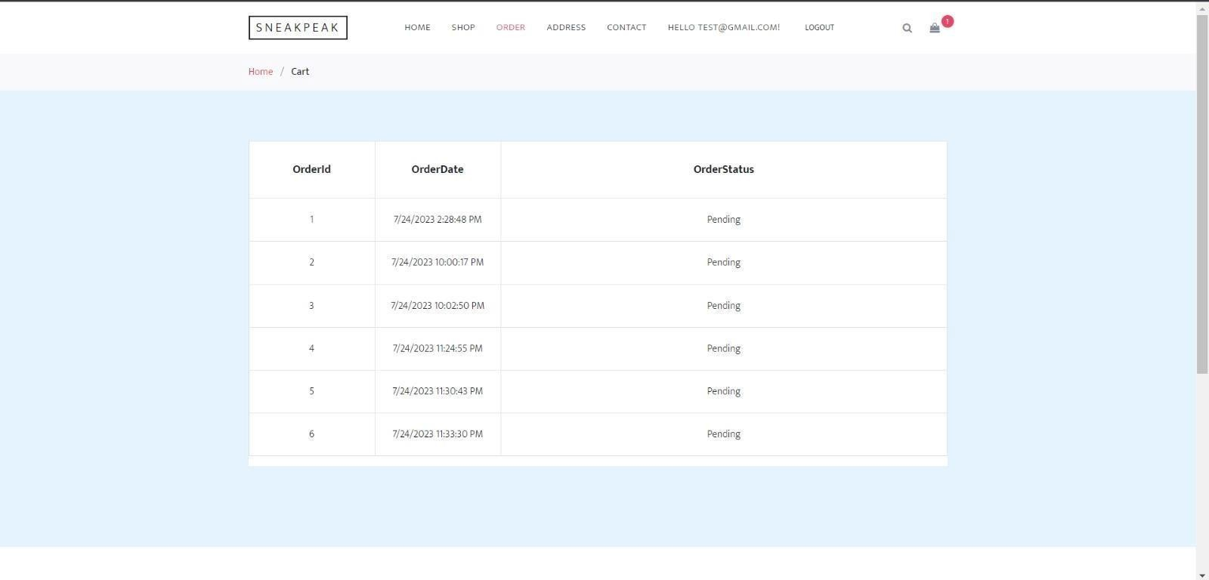

# Enhancements

## Deployed application using CI/CD pipeline:

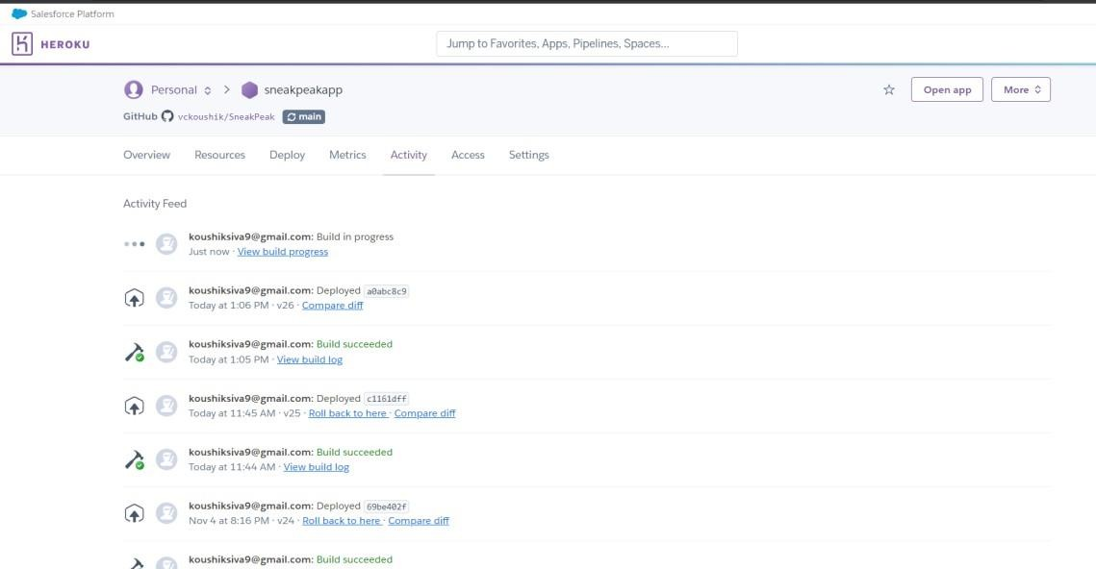

1. **Added payment gateways:** Payment gateways have been incorporated to offer customers secure and adaptable payment choices, ultimately enhancing the checkout experience.

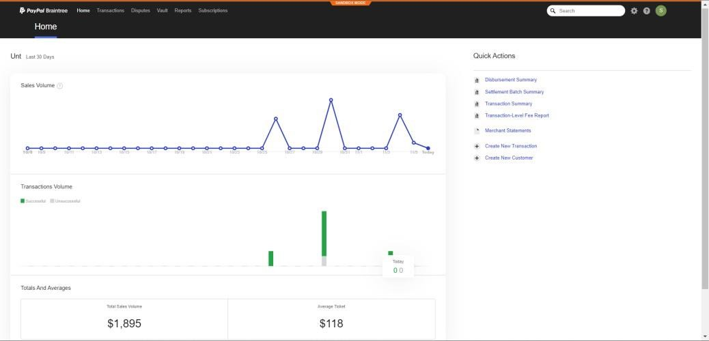

1. **Order details page:** The inclusion of an order details page enables customers to conveniently monitor and assess their orders, thereby improving transparency and post- purchase interaction.

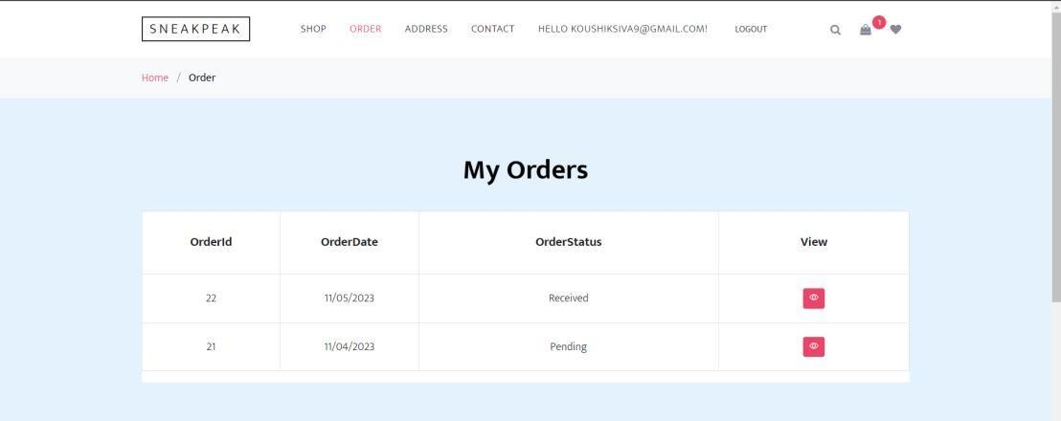

1. **Admin-side enhancement:** An enhancement will be made to the admin interface to optimize the management and control processes, ultimately boosting efficiency, and improving the user- friendliness for administrators.

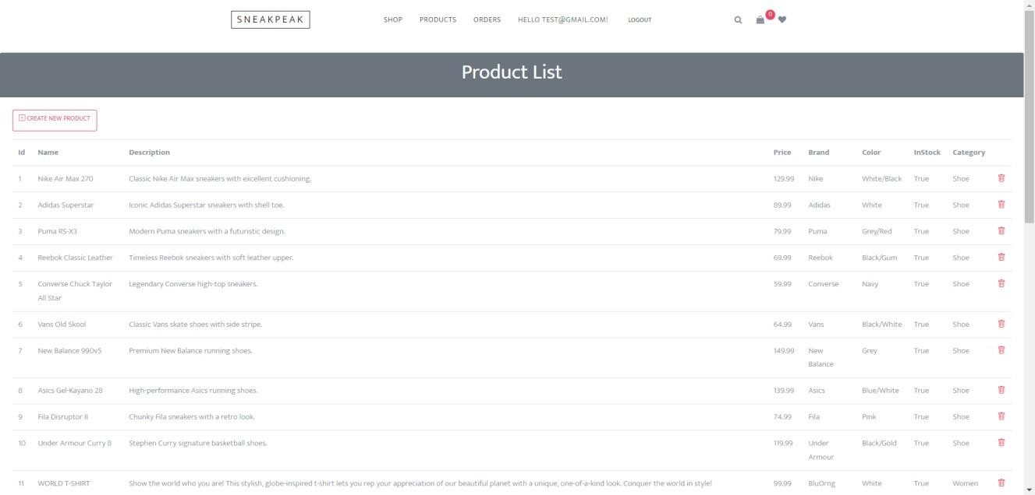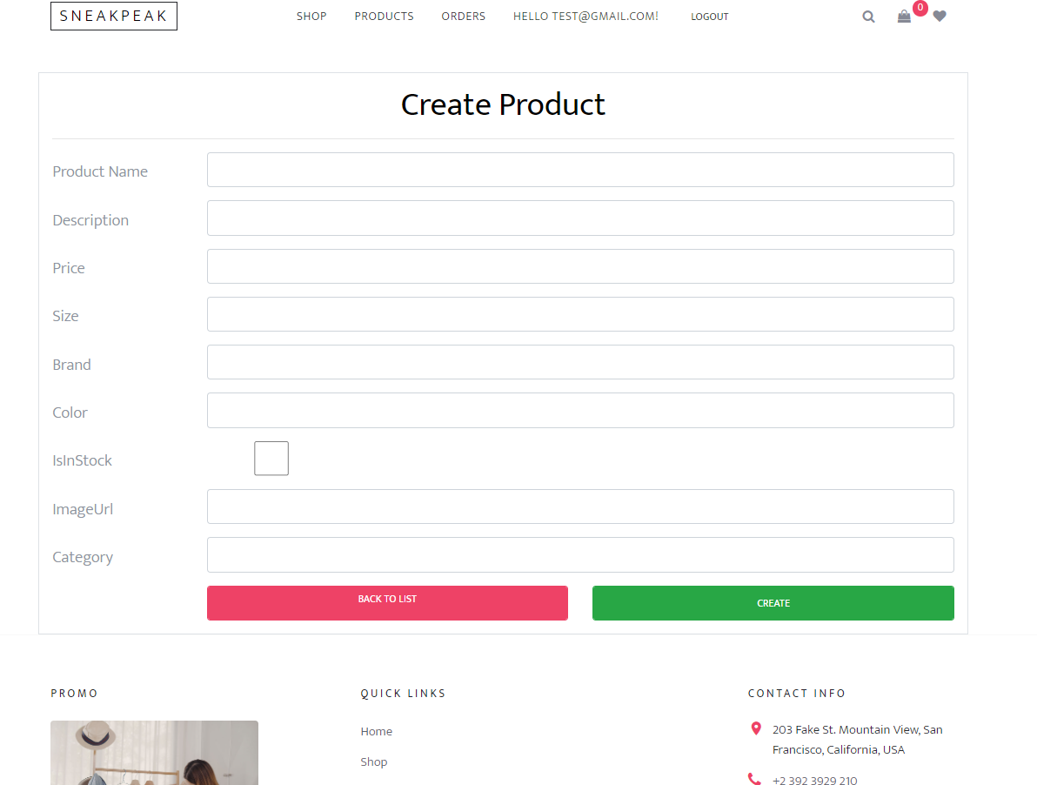

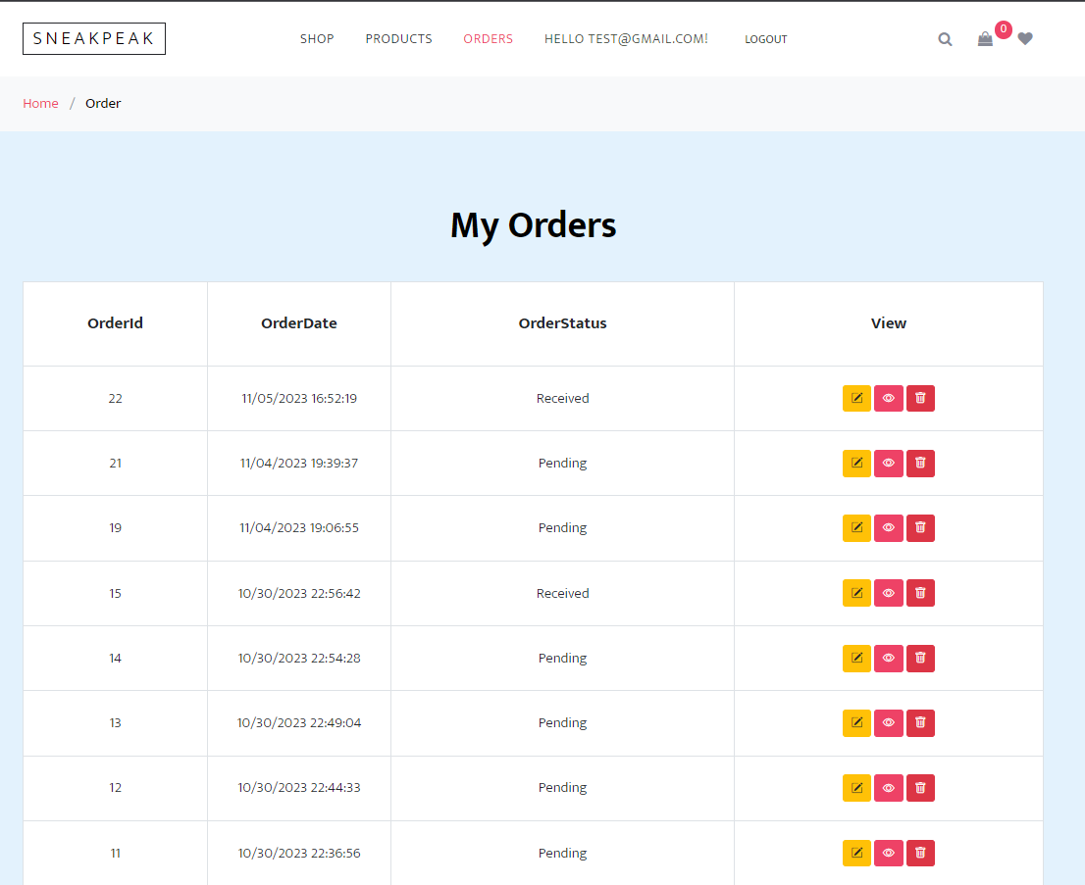

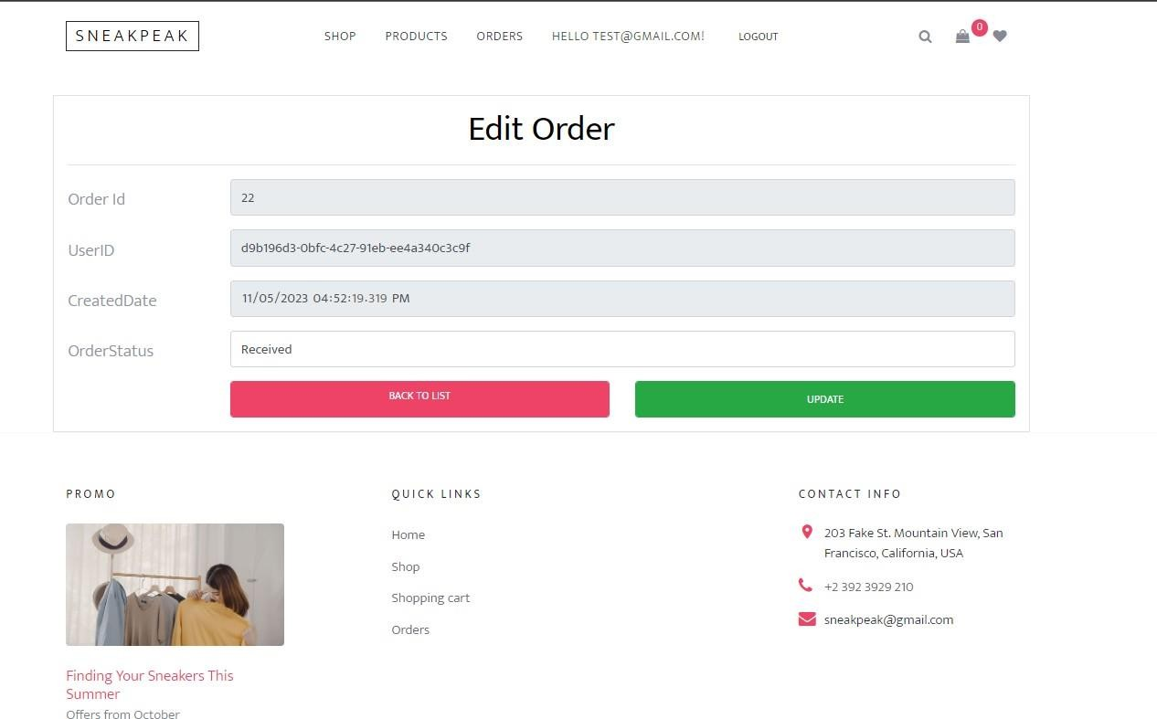

1. **Notified for placed orders:** ensuring that administrators can receive real-time notifications when new orders are submitted.

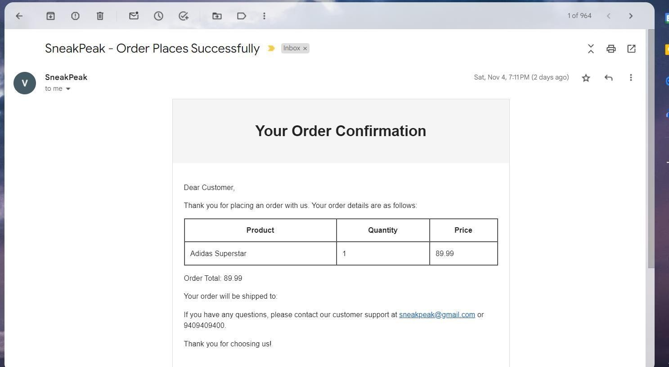

**Other Defects Identified**

1. Clicking on the "Sneak Peak" image on the top left, it took me to an empty page - FIXED, added the correct hyperlink.
2. No size selector for products - Added new dropdown to select size.
3. Email and Phone Number not validated -

Added validation code for Email and Phone number.

1. On the checkout page, when scrolled down and clicked on "Finding Your Sneakers This Summer" it doesn’t work -

Fixed the issue to navigates to correct page.

1. Clicking "Home" at the bottom doesn't work - Fixed it with correct Hyper Link
2. When clicked on the "Shopping Cart" at the bottom, it takes user to a cart of items that they didn't add -

Fixed the cart shopping cart navigation.

1. Contact Page doesn’t work -

Implemented the Contact Page with require APIs and Tables.